Creating Help Files
Help files use panel groups. You create the source for panel groups in the QPNLSRC file. There is one in FABLIBR you can reference.

Contents
Creating a Help Text Panel Group 2
Creating help text using UIM 2
PNLGRP/EPNLGRP - Panel group start and end 3
HELP/EHELP - Help sections 3
Hx - Headings 4
P - Paragraph 5
XMP – Example Text 5
HPx/EHPx - Highlighting 6
UL/EUL - Unordered list 7
OL/EOL - Ordered list 8
SL/ESL - Simple list 9
LINK/ELINK - Link 9
Creating the Panel Group Object 11
Adding Help Text to Commands 11
More Options 11
Command Help Text Standards 12
Adding Help Text to Display Files 13

Creating a Help Text Panel Group
I borrowed, ok straight copied, most of this from http://www.rpgpgm.com/2017/02/creating-help-text-using-uim.html, you can reference the site for more information.

Creating help text using UIM
Thanks to UIM, User Interface Manager, designing help for your DDS display files is very simple. UIM has been used by IBM for their screens, menus, and help panels since the launch of the AS400, it was not until V2R1, 1991, that it was made available to programmers to create their own help panels. The "language" itself is easy to become familiar with and its compile listings are some of the easiest to decipher on IBM i.
In this post I am going to show how to create UIM help panels that can be used in DDS display files, and in a second post how to add the various DDS keywords to your Display file source code to use the UIM help panels.
Let me start with the basics. If you use the IBM convention for source files, help panel groups should be placed in the source file QPNLSRC. Personally, I put all my source members for each library in one source file. The source type for Panel Groups is PNLGRP. Over the years I have come to conclusion that it is best to create one help panel group per application, rather than one per display file. Most of the fields in any application will be shown in multiple display files, and by using one help panel group I can use the same help text in multiple display files. As the help is external to the display files, I can change the panel group without having to recompile the display file.
Work with Members Using PDM
File . . . . . . DEVSRC
Library . . . . MYLIB

Opt Member Type Text
TESTHELP PNLGRP Help text

All UIM source statements start with a tag. Many tags can come in pairs, reminiscent of HTML, one to begin and one at the end. Tags start with a colon ( : ), and end with a period/dot ( . ).
A comment line starts with a period/dot followed by an asterisk ( .* ). Every panel's first "active" statement must be :PNLGRP. and end with an :EPNLGRP., comment lines may be placed before or after these tags.
All statements start in the first column of the source member.
- PNLGRP/EPNLGRP - Start and end of the panel group (source member)
- HELP/EHELP - Start and end of a section of help text
- Hx - Start and end of extended heading
- P - Paragraph
- HPx/EHPx - Start and end of highlighting
- UL/EUL - Start and end of an unordered list
- OL/EOL - Start and end of an ordered list
- SL/ESL - Start and end of a simple list
- LI - List item
- LINK/ELINK - Start and end of a link
There are other UIM tags that can be used in help panel groups. I am not going to list them here, but refer you to the link to the IBM documentation referenced in the More Options section of this document.

PNLGRP/EPNLGRP - Panel group start and end
All panel groups mist start with a PNLGRP and end with a matching EPNLGRP. These must occur only once in the source member.
As I mentioned earlier all tags start with a colon ( : ), and end with a period/dot ( . ).
...+... 1 ...+... 2 ...+... 3 ...
*************** Beginning of data
01 :PNLGRP.
.********************************

.********************************
02 :EPNLGRP.

HELP/EHELP - Help sections
A help panel group can contain one of more help sections.
01 :PNLGRP.
.***************************
02 :HELP NAME='FIRST_EXAMPLE'.
03 First example.

04 :EHELP.
.***************************
05 :HELP NAME='SECOND_EXAMPLE'.
06 Second example.

07 :EHELP.
.***************************
08 :EPNLGRP.

Line 1: The panel group must start with a PNLGRP tag.
Line 2: This is the first section of help text, and it needs a name so that I can define it in the DDS of the display file.
Line 3: This is the heading that will be shown at the top of the help panel when it is displayed.
Line 4: End of the section of help text.
Lines 5 – 7: A second section of help text.
Line 8: The panel group must end with a EPNLGRP tag.

Hx - Headings
There are four levels of heading, adding an X in front makes the heading only be displayed when the extended help is used. There will be examples of this in the command help text defaults section:
- H1,XH1 - Centered, highlighted/bold, and underlined
- H2,XH2 - Left justified, highlighted/bold, and underlined
- H3,XH3 - Left justified, highlighted/bold, and not underlined
- H4,XH4 - Left justified, not highlighted/bold, and underlined
01 :HELP NAME='FIRST_EXAMPLE'.
02 First example - Headings.
03 :XH1.Heading 1
04 :XH2.Heading 2
05 :XH3.Heading 3
06 :XH4.Heading 4
07 :EHELP.

There is no matching closing tag.
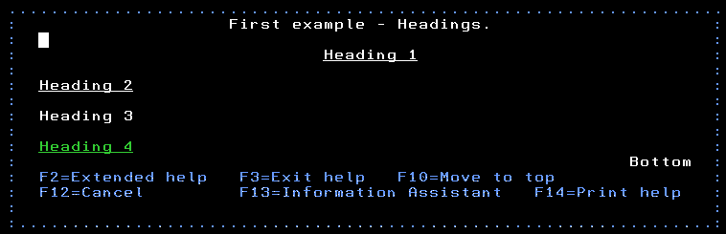
Click on image to see a larger version

P - Paragraph
The help text I want to display needs to be entered after a paragraph tag.
01 :HELP NAME='SECOND_EXAMPLE'.
02 Second example - Paragraphs.
03 :H1.Paragraphs
04 :P.This is my first paragraph.
05 :P.I have another paragraph here!
06 :EHELP.

There is no matching closing tag.
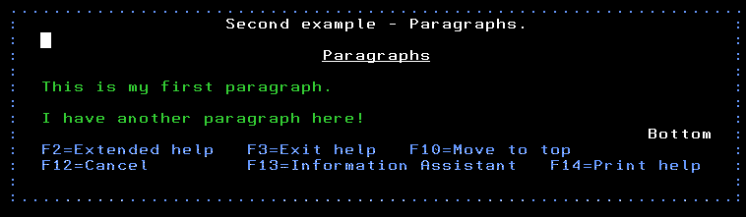
Click on image to see a larger version

XMP – Example Text
Example text displays the text exactly as it is entered in the source. Lines are wrapped only if they do not fit on a line and spacing is preserved. This is mainly used for code examples. The tag must start with :XMP. And end with :EXMP. All text between the beginning and end tag is treated like example text.

HPx/EHPx - Highlighting
The codes for highlighting a section of text must be included within a paragraph. This is a tag that needs to be closed with an ending tag. There are nine types of highlighting.
- HP1/EHP1 - Underlined
- HP2/EHP2 - Highlighted/bold
- HP3/EHP3 - Highlighted/bold and underlined
- HP4/EHP4 - Normal text
- HP5/EHP5 - Reverse image
- HP6/EHP6 - Reverse image and underlined
- HP7/EHP7 - Reverse image and highlighted/bold
- HP8/EHP8 - Reverse image and highlighted/bold (appears to be same as HP7)
- HP9/EHP9 - Reverse image (appears to be same as HP5)
01 :HELP NAME='THIRD_EXAMPLE'.
02 Third example - Highlighting.
03 :H1.Highlighting
04 :P.Highlighting occurs within a paragraph.
05 :P.:HP1.Highlighting 1:EHP1.
06 :P.:HP2.Highlighting 2:EHP2.
07 :P.:HP3.Highlighting 3:EHP3.
08 :P.:HP4.Highlighting 4:EHP4.
09 :P.:HP5.Highlighting 5:EHP5.
10 :P.:HP6.Highlighting 6:EHP6.
11 :P.:HP7.Highlighting 7:EHP7.
12 :P.:HP8.Highlighting 8:EHP8.
13 :P.:HP9.Highlighting 9:EHP9.
14 :EHELP.

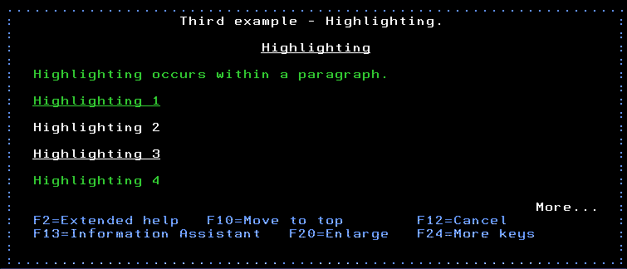
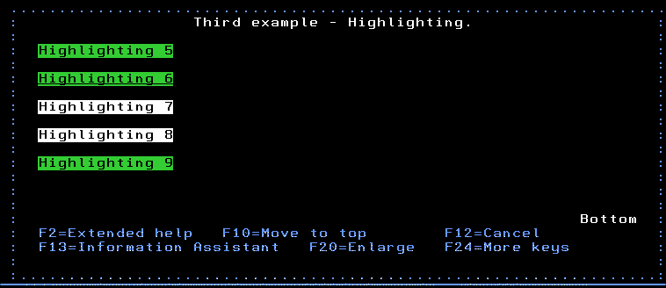
Click on images to see a larger version

UL/EUL - Unordered list
If I wanted to display a list of valid values it is easier on the eye if the items are displayed in a list, rather than separate paragraphs. If I want that list to be prefix with a bullet I use the unordered list. The UL tag is used to indicate that an unordered list is starting, see line 5 below. Each item within the list is prefixed with a list item tag, LI, lines 6 – 8. After the last list item the listed needs to be ended with a EUL tag, line 9.
Line 4 gives an example of how a paragraph can be "overflowed" onto a second line of source code.
01 :HELP NAME='FOURTH_EXAMPLE'.
02 Fourth example - Unordered list.
03 :H1.Unordered list
04 :P.An unordered list looks better than
multiple paragraphs.
05 :UL.
06 :LI.One
07 :LI.Two
08 :LI.Three
09 :EUL.
10 :EHELP.

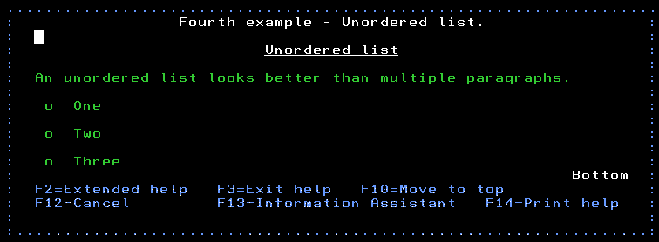
Click on image to see a larger version

OL/EOL - Ordered list
The difference between an unordered and an ordered list is that the ordered list items are numbered. The tag for starting an ordered list is OL, see line 5 below. The list items use the LI tag, as they do the in the unordered list. The ordered list is closed with the EOL tag, line 9.
01 :HELP NAME='FIFTH_EXAMPLE'.
02 Fifth example - Ordered list.
03 :H1.Ordered list
04 :P.An ordered list gives each item a
number.
05 :OL.
06 :LI.One
07 :LI.Two
08 :LI.Three
09 :EOL.
10 :EHELP.

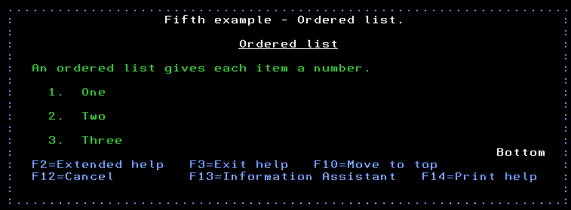
Click on image to see a larger version

SL/ESL - Simple list
List items within a simple list do not have a prefixing character, like the other two types of lists, and are indented like the other types of list's items. The items in simple list are separated with a blank line. The SL, line 5 below, and the ESL, line 9, are used to designate that the list will be a simple list.
01 :HELP NAME='SIXTH_EXAMPLE'.
02 Sixth example - Simple list.
03 :H1.Ordered list
04 :P.An simple list has no character at
start of the line before the list item's
text.
05 :SL.
06 :LI.One
07 :LI.Two
08 :LI.Three
09 :ESL.
10 :EHELP.

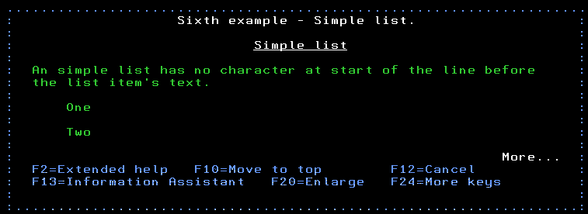
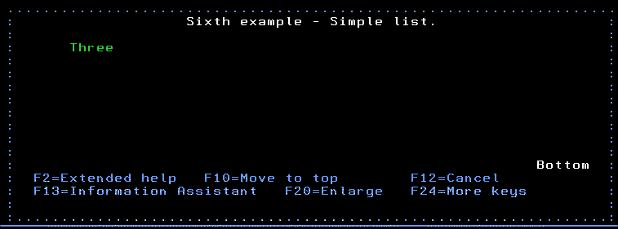
Click on images to see a larger version

LINK/ELINK - Link
The link tag creates a link to another section of help text, which can be within the same panel group or another. All links start with the LINK tag which includes a PERFORM statement defining where the link will go to. Line 6 shows a link within the same panel group, and line 9 shows a link to another panel group. Link text follows, and the link is closed with the ELINK tag.
01 :HELP NAME='SEVENTH_EXAMPLE'.
02 Seventh example - Link.
03 :H1.Link
04 :P.Here is a link to another section of
05 help text
06 :LINK PERFORM='DSPHELP FIRST_EXAMPLE'.
07 first example:ELINK., and here is a second
08 link
09 :LINK PERFORM='DSPHELP SECOND_UIM OTHER_UIM'.
10 second example:ELINK..
11 :EHELP.

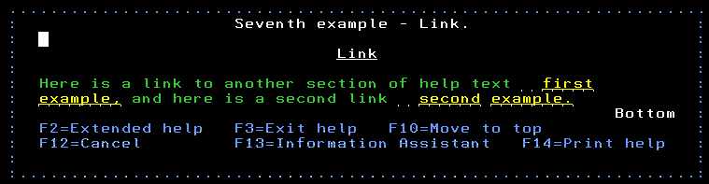
Links are displayed as underlined and yellow. To visit the linked help section I position my cursor on the link text and press the Enter key. Notice how there is a blank character before the link text, this indicates if the link has been visited or not. In the image below the greater than symbol ( > ) shows that I have visited the first link.
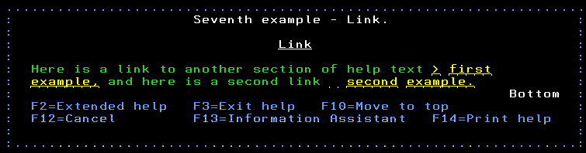

Creating the Panel Group Object
Use the command CRTPNLGRP to create the panel group object. You can also use option 14 in PDM without having to prompt it.
Example:
CRTPNLGRP PNLGRP(FABLIBR/CNTVAR)
SRCFILE(FABLIBR/QPNLSRC)
TEXT('Help Text For CNTVAR')

Adding Help Text to Commands
For commands the panel group can be added to the CRTCMD command. The following example is for the CNTVAR command in FABLIBR.
CRTCMD CMD(FABLIBR/CNTVAR)
PGM(*LIBL/CNTVAR)
SRCFILE(FABLIBR/QCMDSRC)
SRCMBR(CNTVAR)
ALLOW(*IPGM *BPGM)
HLPPNLGRP(CNTVAR)
HLPID(CNTVAR)
REPLACE(*YES)

It uses the PNLGRP CNTVAR which contains a help ID of CNTVAR.
A better option is to put the help information in the command source. Going forward this should be the preferred method because the programmer will not have to remember to add it to the create command. The following example is from the command EMLSQL.
0005.00 CMD PROMPT('Email SQL as Excel') TEXT(*CMDPMT) +
0006.00 HLPID(EMLSQL) HLPPNLGRP(EMLSQL)
0007.00
The HLPPNLGRP and HLPID will be pulled from the source when the command is created.

More Options
This document does not contain all the tags used in a UIM panel group. There are a lot more available. The best document I have with them defined is the V5R4 Application Display Programming manual form IBM. There is a copy of it in D:\Is\IS47\Documentation, the file name is Application Display Programming V5R4M0.pdf. Around page 400 the tags are all listed.

Command Help Text Standards
TODO

Adding Help Text to Display Files
Having created a UIM help panel group I need to add the code to my Display file's DDS so that the help will be displayed. This post is going to use the UIM panel group that was created in my previous post to demonstrate, in simple terms, how to do this. I have designed a very simple display file to only include what I think is the minimum needed for it to work.
Most people have no idea where to find the Help key in their 5250 emulation client, therefore, as per SAA CUA standards I always define F1 as an alternate help key. I define the alternate help key in the file level keywords, top before the first record format definition, of the display file.
Rather than use SDA I find it easier to enter this source code using a source code editor, for example SEU. Therefore, I will be describing how to add this code as if I am using a source code editor.
AAN01N02N03T.Name++++++RLen++TDpBLinPosFunctions++++++++++++++++++++++++
01 A DSPSIZ(24 80 *DS3)
02 A HELP
03 A ALTHELP(CA01)
04 A HLPPNLGRP('START' HELP_UIM)
05 A HLPTITLE('Example display file')
06 A HLPFULL

Line 2: I activate the Help key with the HELP function. You never know someone may know where their help key is.
Line 3: This is where I define F1 as the alternate help key. Notice that I have defined the key indicator to be command attention, CA01.
Lines 4 – 6: Are optional.
Line 4: I will describe the HLPPNLGRP function later. This is the help text that will be displayed at the beginning of the Extended Help. Defined at the file level this help text will be displayed at the start of the Extended Help for all the record formats within this display file. If I do not want this for all record formats I define this function in the record format. It cannot be defined in both places.
Line 5: This is the title that will be used at the top of the Extended Help, and works the same way as the HELPPNLGRP function on line 4
Line 6: The presence of the HLPFULL function will make the help text display on the full screen, not in a pop up window. If this function is absent the help will be displayed as defined in the User Options parameter, USROPT, of my user profile.
I am not going to show all the code for the record format within this display file, just the parts to do with the definition of the help text. The rest of the record format, the definition of the fields, is irrelevant as defining the help is not dependent upon the types of the fields.
07 A R SCREEN
08 A HLPCLR
09 A* HLPTITLE('Example rcd format')
10 A H HLPPNLGRP('FIRST_EXAMPLE' +
HELP_UIM)
11 A HLPARA(*FLD Z1)
12 A H HLPPNLGRP('SECOND_EXAMPLE' +
HELP_UIM)
13 A HLPARA(3 10 3 15)
14 A H HLPPNLGRP('THIRD_EXAMPLE' +
HELP_UIM)
15 A HLPARA(*FLD Z3)
16 A H HLPPNLGRP('FOURTH_EXAMPLE' +
HELP_UIM)
17 A HLPARA(*FLD Z4)
18 A H HLPPNLGRP('FIFTH_EXAMPLE' +
HELP_UIM)
19 A HLPARA(*FLD Z5)
20 A H HLPPNLGRP('SIXTH_EXAMPLE' +
HELP_UIM)
21 A HLPARA(*FLD Z6)
22 A H HLPPNLGRP('SEVENTH_EXAMPLE' +
HELP_UIM)
23 A HLPARA(*FLD Z7A)
24 A H HLPPNLGRP('SEVENTH_EXAMPLE' +
HELP_UIM)
25 A HLPARA(*FLD Z7B)
26 A HLPEXCLD
27 A H HLPPNLGRP('NOT_EXIST' HELP_UIM)
28 A HLPARA(*FLD Z8)

Line 7: Record format name.
Line 8: HLPCLR when used at the record format level clears any active help specifications.
Line 9: I can define the HLPTITLE at the record format level as well as in the file level. As in this example I gave it at the file level I have commented out this line.
Lines 10 and 11: Here is the first definition for help. The H is in the 17th column, which is the same place the R is placed for the definition of the record format name. The HLPPNLGRP function defines the name of the help section in the UIM panel group. It needs to be given with the name of the help section first, followed by the name of the UIM panel group. As the panel group HELP_UIM is in my library list I do not have to give the library name with name of the panel group.
The HLPARA keyword comes in three flavors.
AAN01N02N03T.Name++++++RLen++TDpBLinPosFunctions++++++++++++++++++++++++
A1 A H HLPPNLGRP('FIELD_1' HELP_UIM)
A2 A HLPARA(3 2 3 4)
B1 A H HLPPNLGRP('FIELD_2' HELP_UIM)
B2 A HLPARA(*FLD Z1)
C1 A H HLPPNLGRP('RCDFMT_1' HELP_UIM)
C2 A HLPARA(*RCD)

Line A2: HLPARA(3 2 3 4) - Defines the help for an area of the record format. This help will be displayed in the area from the third row/second column to the third row/fourth column.
Line B2: HLPARA(*FLD Z1) - Defines the help for the field Z1. I prefer this method because if I move Z1 to another part of the display I do not have to change the HLPARA, which I would have to if I had defined it using the previous way.
Line C2: HLPARA(*RCD) - Defines the help text for the entire record format, except where help has been defined using the two previous methods.
OK, back to the DDS source code for all the help definitions in the record format SCREEN. The rest of all this source code, lines 12 – 28, are the same as line 10 and 11, just defining the help for various fields or areas of the screen, except…
Line 26: HLPEXCLD excludes the line from appearing in the Extended Help. In this example I have same help defined for fields Z1 and Z2. When the Extended Help is displayed I only want this help displayed once, not twice.
Lines 27 and 28: There is no help called NOT_EXIST, therefore, if the field Z8, is "helped" a help screen like this is displayed.
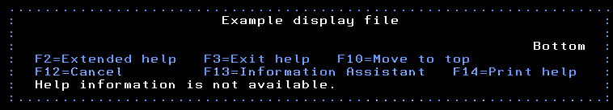
When I see this I find I have misspelled the help name in the DDS.
So, what is Extended Help?
In the help panel I can see F2=Extended help. If I press F2 all of the help for that record format is displayed in the order the help specifications are placed in the record format's source code, not the order of the fields. The screen below is shown in full screen mode, as I added the HLPFULL function to the display file's source.
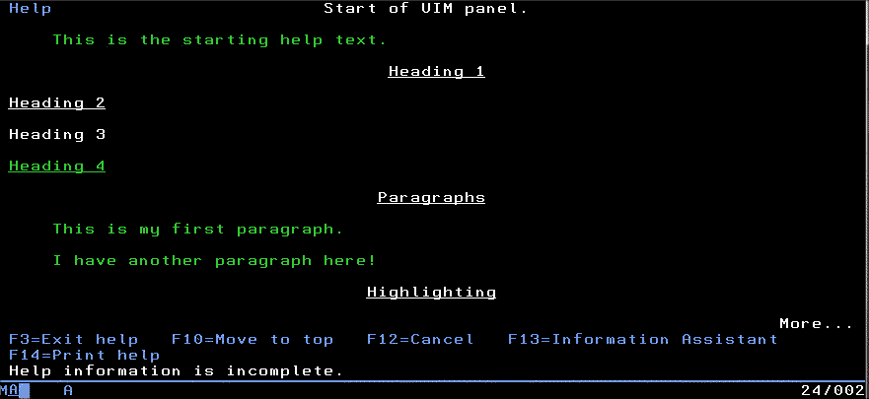
The error message "Help information is incomplete" is displayed as the help called NOT_EXIST is not present in the help panel group.
Help can only be shown when it is defined in the record format that is displayed using EXFMT. With a subfile, SFL, it is the subfile control, SFLCTL, that is EXFMT, therefore, the help for the subfile has to be placed in the subfile control record. As the subfile's fields are not defined in the control record format I have to define the area upon which this subfile field will be displayed.
A H HLPPNLGRP(INV_NBR ORDHELP)
A HLPARA(06 010 22 017)

One last recommendation I would make is to display F1=Help with the other function keys on any display file/record format you have added help to. This alerts the people using the display file that help is available to them. If you don't people will not know it is there.
F1=Help F3=Exit F4=Prompt

You can learn more about this from the IBM website:
- HLPARA - Help area
- HLPCLR - Help clear
- HLPEXCLD - Help exclude
- HLPPNLGRP - Help panel group
- HLPTITLE - Help title

This article was written for IBM i 7.3, and should work for earlier releases too.

